PHP SLIP PROGRAMS

Name : Prajkta wadlekar.

Roll no : 46.

Sub : PHP.

1. Write a program using Conditional Structure.

<?php

$marks=75;

if($marks>79){

echo"A";

}

elseif($marks<=79 && $marks>60){

echo"B";

}

elseif($marks<=60 && $marks>50){

echo"C";

}

elseif($marks=50){

echo"D";

}

else{

echo"F";

}

?>

**Output:**

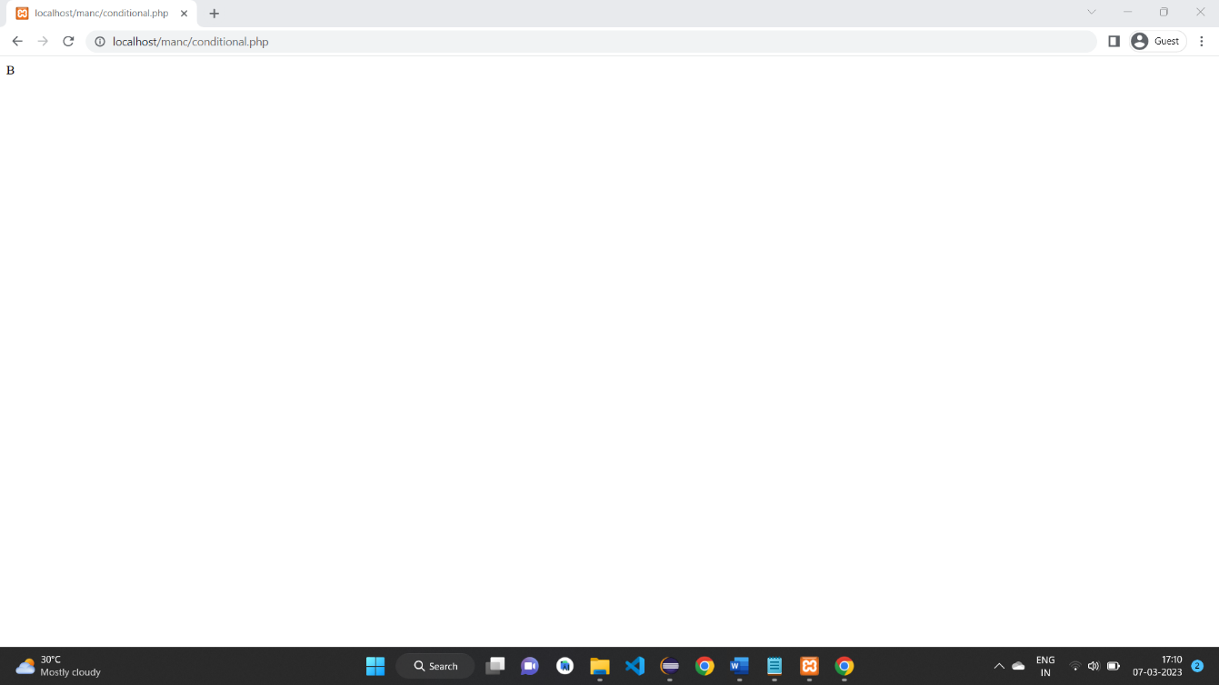

2.Write a program using array which accepts five values and print the values.

<?php

$colors=array("MBA","MCA","M.COM","BCA","BBA");

foreach($colors as $value){

echo "$value<br>";

}

?>

**Output:**

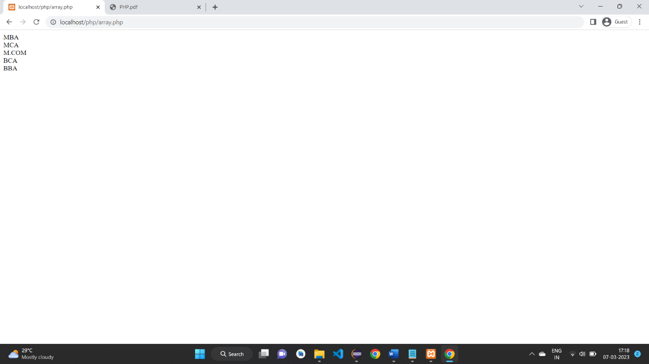

3.Write a program using Looping Structure with concept of Functions.

<?php

function addNumbers(int $a,int $b){

echo $a+$b;

}

$x=1;

do{

echo"The number is : $x<br>";

$x++;

}

while($x<=5);

$x++;

addNumbers(5,"5");

?>

**Output:**

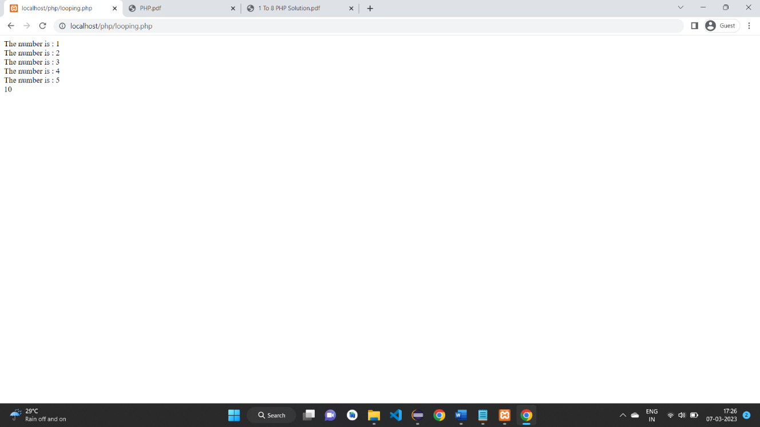

4. Write a program in PHP for type casting of a variable.

<?php

$a=15.5; //float to integer

var_dump($a);

echo' = to = ';

$a=(int)$a;

var_dump($a);

echo'<br>';

$b=92.2222; //float to integer

var_dump($b);

echo' = to = ';

$b=(int)$b;

var_dump($b);

echo'<br>';

$c=21637163.666; //float to integer

var_dump($c);

echo' = to = ';

$c=(int)$c;

var_dump($c);

echo'<br>';

$d=-13.77; //signed float to signed integer

var_dump($d);

echo' = to = ';

$d=(int)$d;

var_dump($d);

echo'<br>';

$e='Hello World'; //string to integer

var_dump($e);

echo' = to = ';

$e=(int)$e;

var_dump($e); //0

echo'<br>';

$f='100 USD'; //string to integer

var_dump($f); //100

echo' = to = ';

$f=(int)'372 INR';

var_dump($f);

echo' = to = ';

$f=null;

var_dump((int)$f); //0

echo'<br>';

$g=array("Volvo","BMW","Toyota"); //array to integer

var_dump($g);

echo' = to = ';

$g=(int)$g;

var_dump($g);

?>

**Output:**

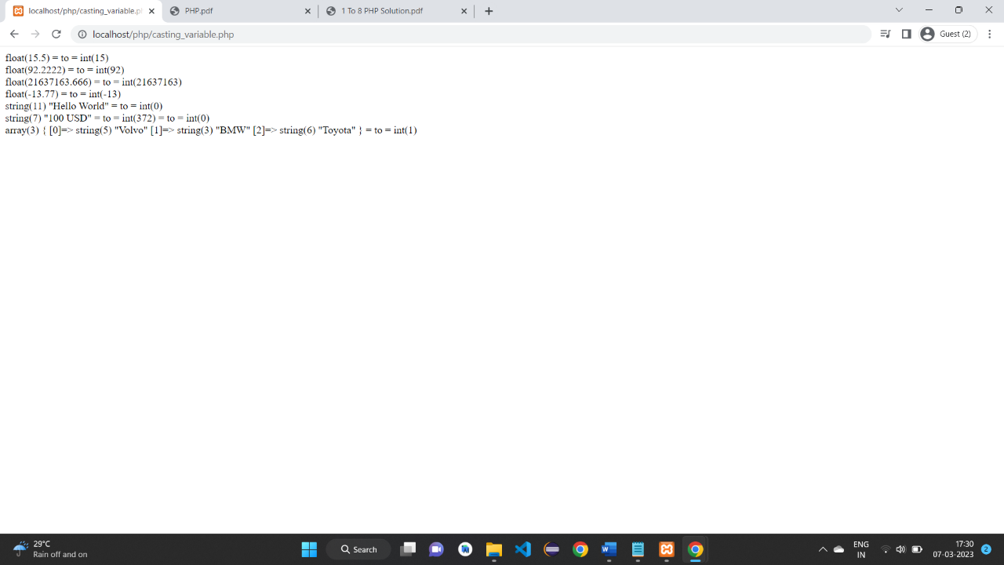

5. Write a program in PHP to display Multiplication Table using nested for loop.

<table align="center" border='1' width="100%">

<?php

$num=10;

for($i=1;$i<=10;$i++)

{

echo"<tr>";

for($j=1;$j<=$num;$j++)

{

$multiplication_table=($i*$j);

echo"<td>$j x $i=$multiplication_table</td>";

}

echo"<tr/>";

}

?>

<table/>

**Output:**

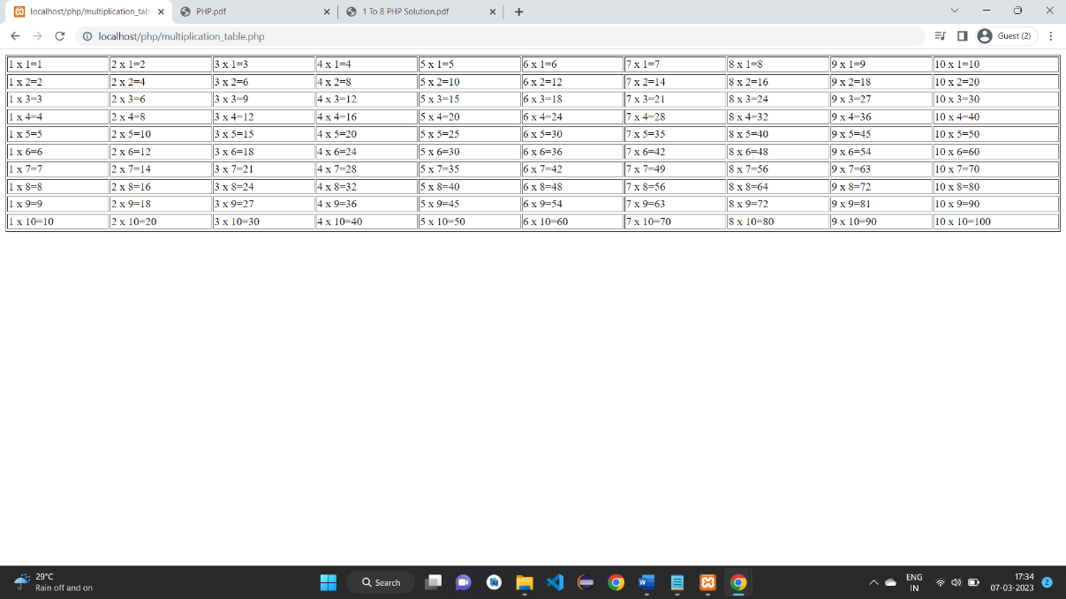

6. Write a program In PHP to Sort an array using Bubble Sort function.

<?php

function bubble_sort($my_array)

{

do

{

$swapped=false;

for($i=0,$c=count($my_array)-1;$i<$c;$i++)

{

if($my_array[$i]>$my_array[$i+1])

{

list($my_array[$i+1],$my_array[$i])=array($my_array[$i],$my_array[$i+1]);

$swapped=true;

}

}

}

while($swapped);

return $my_array;

}

$test_array=array(3,0,2,5,-1,4,1);

echo"Original Array:\n";

echo implode(',',$test_array);

echo "\nSorted Array\n:";

echo implode(',',bubble_Sort($test_array)).PHP_EOL;

?>

**Output:**

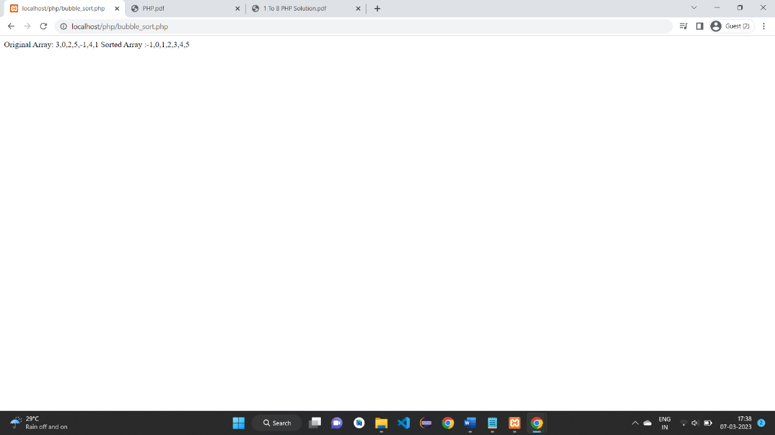

7. Design the personal information form ,submit and retrieve the form data using php $_POST,$_GET,$ REQUEST variable.

Welcome.html:

<html>

<body>

<form action="welcome.php" method="get">

Name:<input type="text" name="name"><br>

E-mail:<input type="text" name="email"><br>

<input type="submit">

</form>

</body>

</html>

Welcome.php:

Welcome <?php echo $_GET["name"];?><br>

Your email address is : <?php echo $_GET["email"];?>

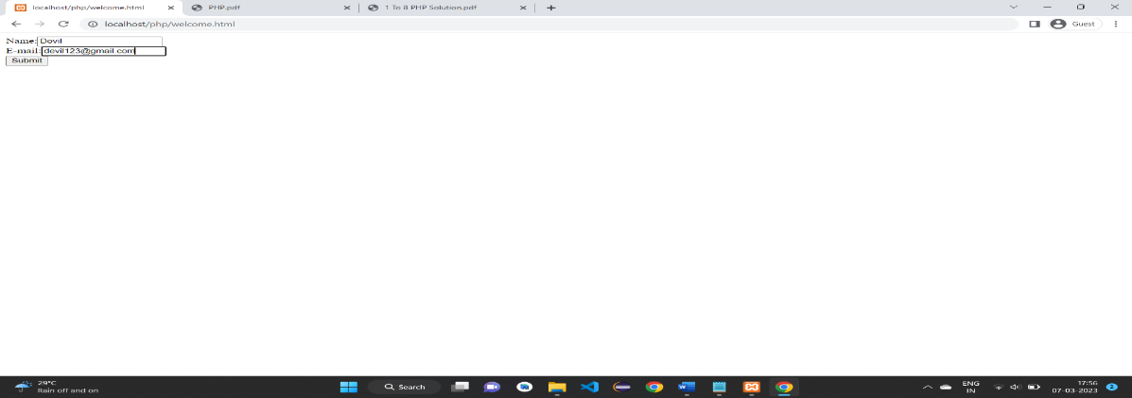

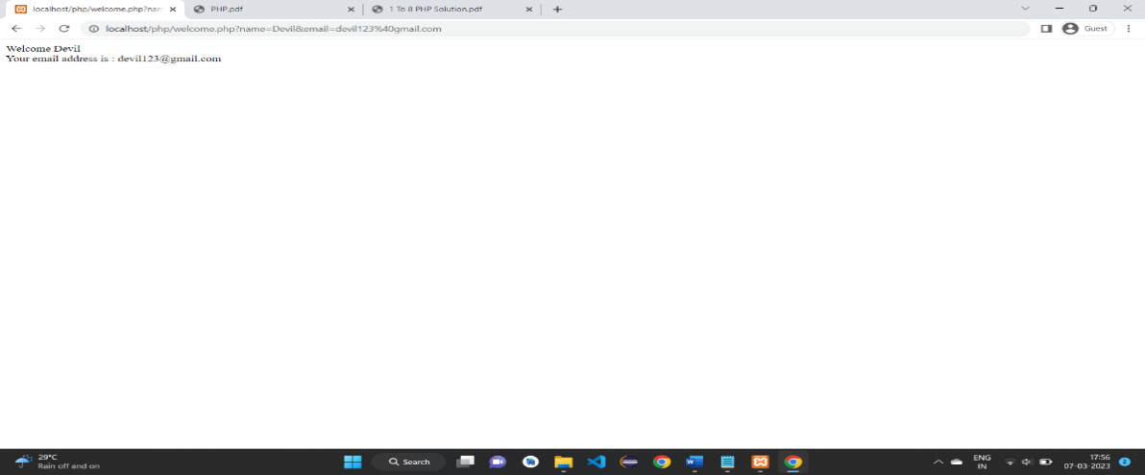

8. Study of Cookies and Session In PHP.

<?php

$cookie_name="user";

$cookie_value="John Doe";

setcookie($cookie_name,$cookie_value,time()+(86400*30),"/"); //86400=1 day

?>

<html>

<body>

<?php

if(!isset($_COOKIE[$cookie_name])){

echo "Cookie named". $cookie_name . " is not set!";

}else{

echo "Cookie". $cookie_name. " is set!<br>";

echo "Value" . $_COOKIE[$cookie_name];

}

?>

</body>

</html>

//Delete a Cookie

<?php

//set the expiration date to one hour ago

setcookie("user","",time()-3600);

?>

<html>

<body>

<?php

echo "Cookie 'user' is deleted .";

?>

</body>

</html>

<?php

setcookie("test_cookie","test",time()+3600,'/');

?>

<html>

<body>

<?php

if(count($_COOKIE)>0){

echo "Cookies are enabled .";

}else{

echo "Cookies are disabled.";

}

?>

</body>

</html>

**Output:**

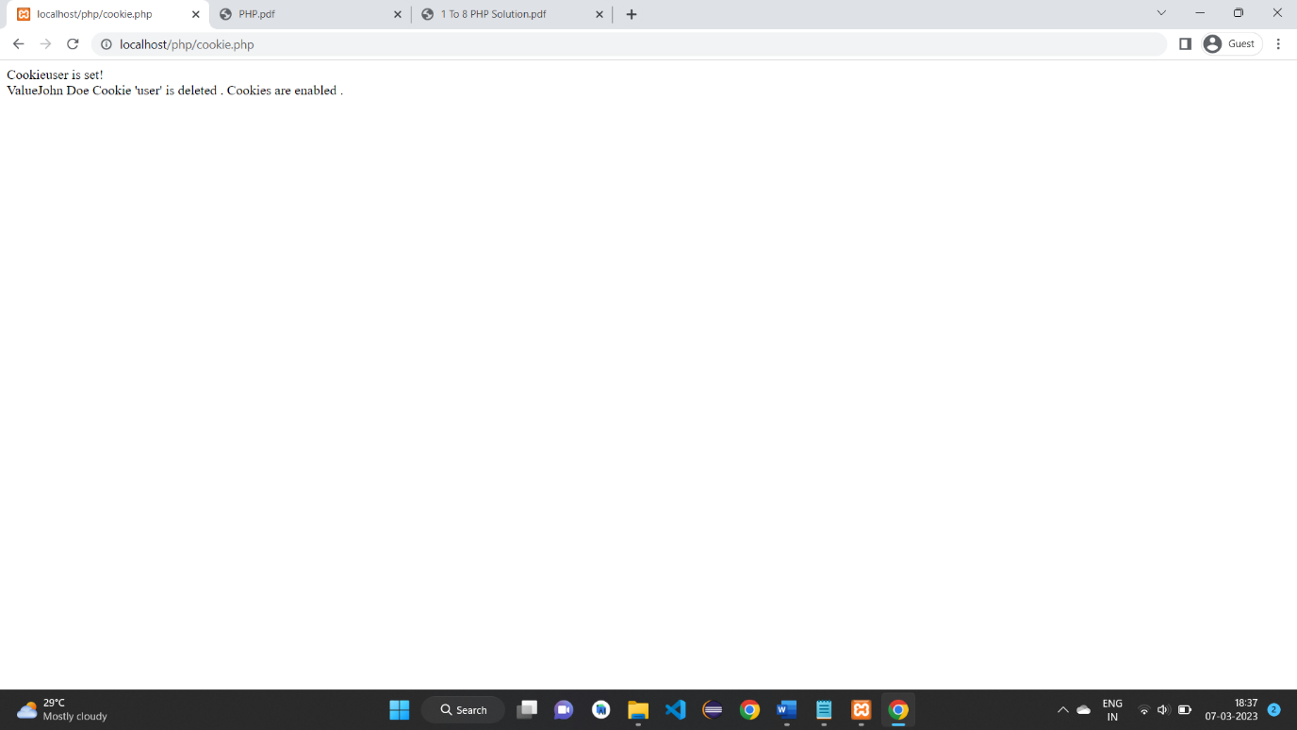

**Session:**

<?php

// Start the session

session_start();

?>

<!DOCTYPE html>

<html>

<body>

<?php

// Set session variables

$_SESSION["favcolor"] = "green";

$_SESSION["favanimal"] = "cat";

echo "Session variables are set.<br>";

//Display or Get PHP Session Variable Values

echo "Favorite color is " . $_SESSION["favcolor"] . ".<br>";

echo "Favorite animal is " . $_SESSION["favanimal"] . ".";

?>

</body>

</html>

**Output:**

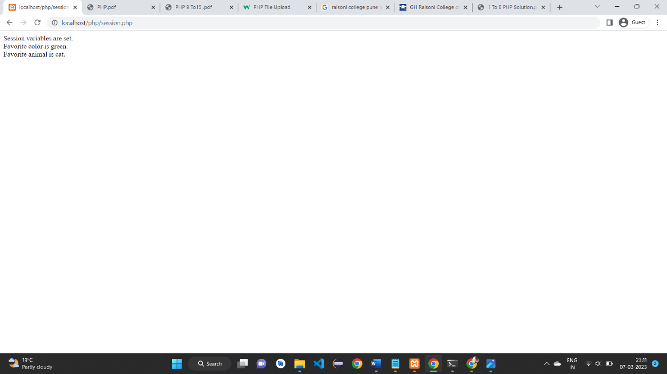

9. Study Of Mysql DDL,DML,DCL Commands.

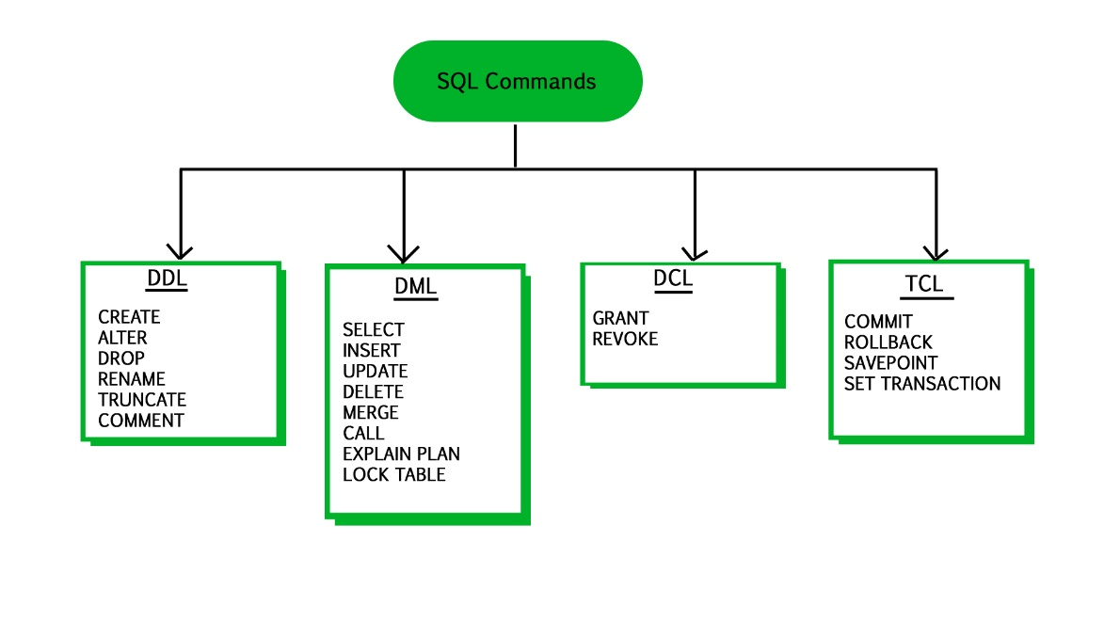

1. Data Definition Language (DDL)

* DDL changes the structure of the table like creating a table, deleting a table, altering a table, etc.
* All the command of DDL are auto-committed that means it permanently save all the changes in the database.

Here are some commands that come under DDL:

* CREATE
* ALTER
* DROP
* TRUNCATE

2. Data Manipulation Language

* DML commands are used to modify the database. It is responsible for all form of changes in the database.
* The command of DML is not auto-committed that means it can't permanently save all the changes in the database. They can be rollback.

Here are some commands that come under DML:

* INSERT
* UPDATE
* DELETE

3. Data Control Language

DCL commands are used to grant and take back authority from any database user.

Here are some commands that come under DCL:

* Grant
* Revoke

4. Transaction Control Language

TCL commands can only use with DML commands like INSERT, DELETE and UPDATE only.

These operations are automatically committed in the database that's why they cannot be used while creating tables or dropping them.

Here are some commands that come under TCL:

* COMMIT
* ROLLBACK
* SAVEPOINT

10.Design Login Form and Validate that form using PHP Code.

<html>

<head>

<style>

.errorColor{color : #D30000;}

</style>

</head>

<body>

<?php

//all required variables defined here

$nameError=$emailError="";

$name=$email=$message="";

if($_SERVER["REQUEST_METHOD"]=="POST"){

if(empty($_POST["name"])){

$nameError ="Name is mandatory";

}else{

$name= test_input($_POST["name"]);

//check if name only contains letter and whitespace

if(!preg_match("/^[a-zA-Z-']*$/",$name)){

$nameError="Only letters allowed";

}

}

if(empty($_POST["email"])){

$emailError="Email is mandatory";

}else{

$email=test_input($_POST["email"]);

//check if e-mail address is well-formed

if(!filter_var($email,FILTER_VALIDATE_EMAIL)){

$emailError="Invalid email format";

}

}

if(empty($_POST["message"])){

$message="";

}else{

$message=test_input($_POST["message"]);

}

}

function test_input($data){

$data=trim($data);

$data=stripslashes($data);

$data=htmlspecialchars($data);

return $data;

}

?>

<h2><u>PHP Form With Validation</u></h2>

<p><span class="errorColor">* mandatory field</span></p>

<form method="post" action="<?php echo

htmlspecialchars($_SERVER["PHP_SELF"]);?>">

Name:<input type="text" name="name">

<span class="errorColor">*<?php echo $nameError;?></span>

<br><br>

E-Mail:<input type="text" name="email">

<span class="errorColor">*<?php echo $emailError;?></span>

<br><br>

Message :<textarea name="message" rows="6" cols="24"></textarea>

<br><br>

<input type="submit" name="submit" value="Submit">

</form>

<?php

echo $name;

echo "<br>";

echo $email;

echo "<br>";

echo $message;

?>

</body>

</html>

**Output:**

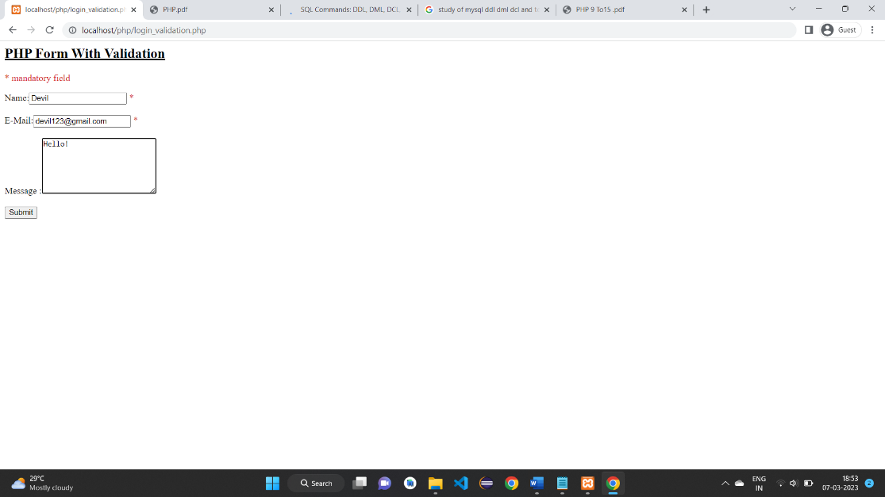

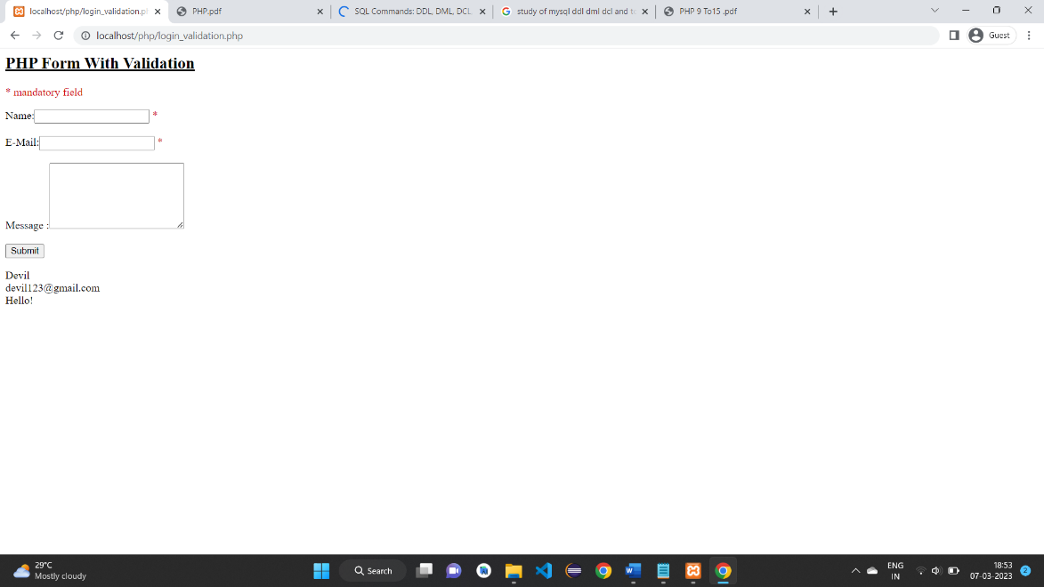

**11.** Write a PHP code to create database & table in Mysql.

**Create Database :**

<?php

$servername = "localhost";

$username = "root";

$password = "12345";

// Database connection establishment

$con=mysqli_connect($servername, $username, $password);

// Create database

if (mysqli_query($con,"CREATE DATABASE ck")) {

echo "Database created successfully";

}else {

echo "Error in creating database: " . mysqli_error($con);

}

?>

**Output:**

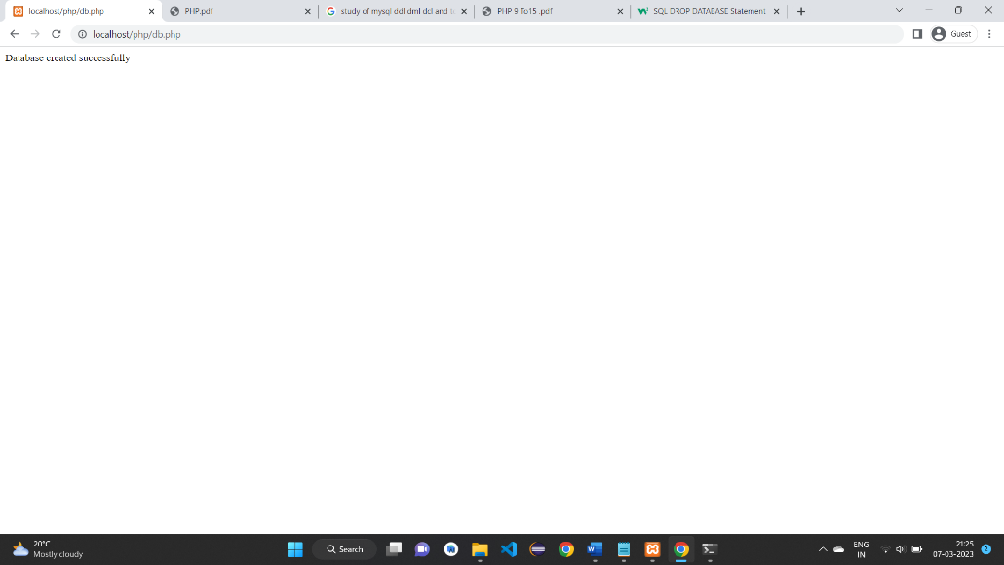

Create table in Database :

<?php

$servername = "localhost";

$username = "root";

$password = "12345";

$dbname = "ck";

// Database connection establishment

$con=mysqli_connect($servername, $username, $password,$dbname);

// Create table query

$query = "CREATE TABLE users(

id INT NOT NULL AUTO_INCREMENT PRIMARY KEY ,

name VARCHAR( 25 ) NOT NULL ,

last_name VARCHAR( 25 ) NOT NULL ,

age INT NOT NULL

)";

// Execute query

if (mysqli_query($con,$query)) {

echo "Table created successfully";

}else {

echo "Error in creating table: " . mysqli_error($con);

}

?>

**Output:**

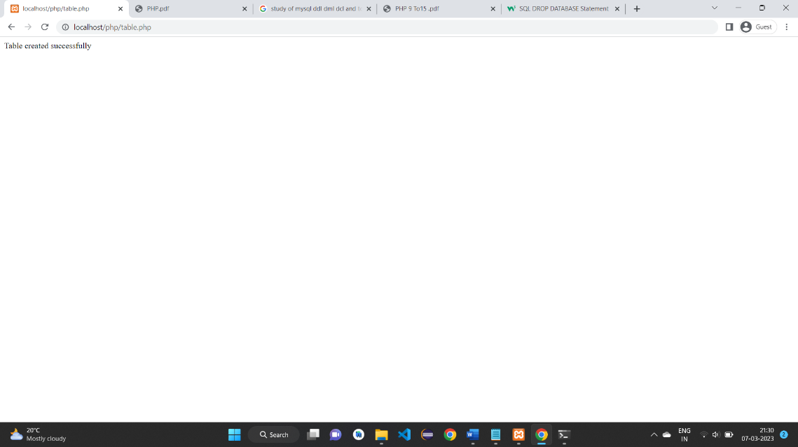

12. Write a PHP code to insert ,delete,select the data from database.

**Create Database** :

<?php

$servername = "localhost";

$username = "root";

$password = "12345";

// I am Creating a connection here with MySQL.

$conn = mysqli_connect($servername, $username, $password);

// I am Checking connection here.

if (!$conn) {

die("Connection failed: " . mysqli_connect_error());

}

// SQL qurey to Creating a database in MySQL.

$sql = "CREATE DATABASE School";

if (mysqli_query($conn, $sql)) {

echo "Database created successfully";

} else {

echo "Error! creating database: " . mysqli_error($conn);

}

mysqli_close($conn);

?>

**Output:**



**Insert Values:**

<?php

$servername = "localhost";

$username = "root";

$password = "12345";

$dbname = "School";

// I am Creating a connection here with MySQL.

$conn = mysqli_connect($servername, $username, $password, $dbname);

// I am Checking connection here.

if (!$conn) {

die("Connection failed: " . mysqli_connect_error());

}

// SQL query to inserting data in students table.

$sql = "INSERT INTO students (stname, email, mobile)

VALUES ('Mohan', 'mohan@example.com', '1122334456')";

if (mysqli_query($conn, $sql)) {

echo "New record inserted successfully";

} else {

echo "Error: " . $sql . "<br>" . mysqli_error($conn);

}

mysqli_close($conn);

?>

**Output:**

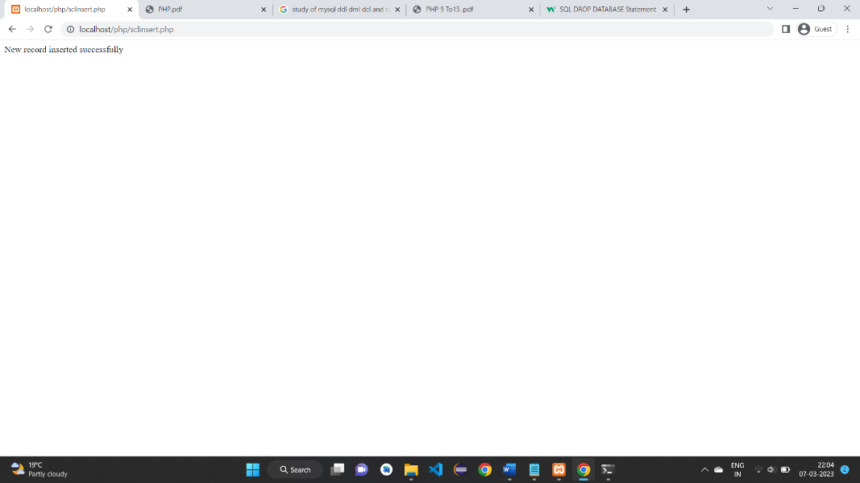

**Select:**

<?php

$servername = "localhost";

$username = "root";

$password = "12345";

$dbname = "School";

// I am Creating a connection here with MySQL.

$conn = mysqli_connect($servername, $username, $password, $dbname);

// I am Checking connection here.

if (!$conn) {

die("Connection failed: " . mysqli_connect_error());

}

// SQL query to selecting all record from table

$sql = "SELECT id, stname, email, mobile FROM students";

$result = mysqli_query($conn, $sql);

if (mysqli_num_rows($result) > 0) {

while($row = mysqli_fetch_assoc($result)) {

echo "<b>Id:</b> " . $row["id"]. ", <b>Name:</b> " . $row["stname"]. ",

<b>Email:</b> " . $row["email"]. ", <b>Mobile:</b> " . $row["mobile"]. "<br>";

}

} else {

echo "no record found";

}

mysqli_close($conn);

?>

**Output:**

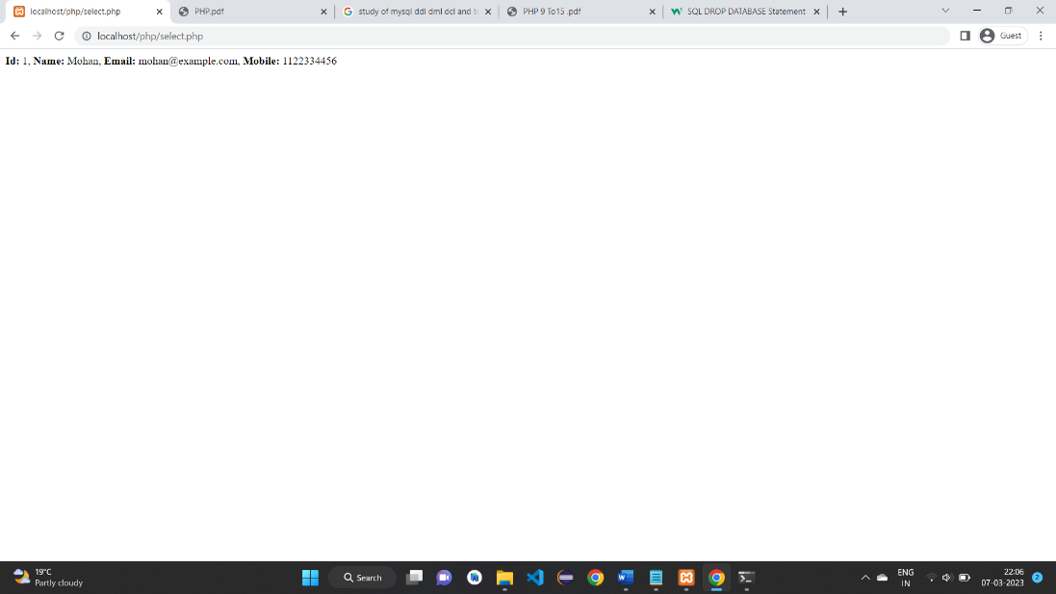

13. Design a from which upload & Display image in PHP.

<html>

<head>

<title>PHP File Upload example</title>

</head>

<body>

<form action="fileupload.php" enctype="multipart/form-data" method="post">

Select image :

<input type="file" name="file"><br/>

<input type="submit" value="Upload" name="Submit1"> <br/>

</form>

<?php

if(isset($_POST['Submit1']))

{

$filepath = "images/" . $_FILES["file"]["name"];

if(move_uploaded_file($_FILES["file"]["tmp_name"], $filepath))

{

echo "<img src=".$filepath." height=200 width=300 />";

}

else

{

echo "Error !!";

}

}

?>

</body>

</html>

**Output:**

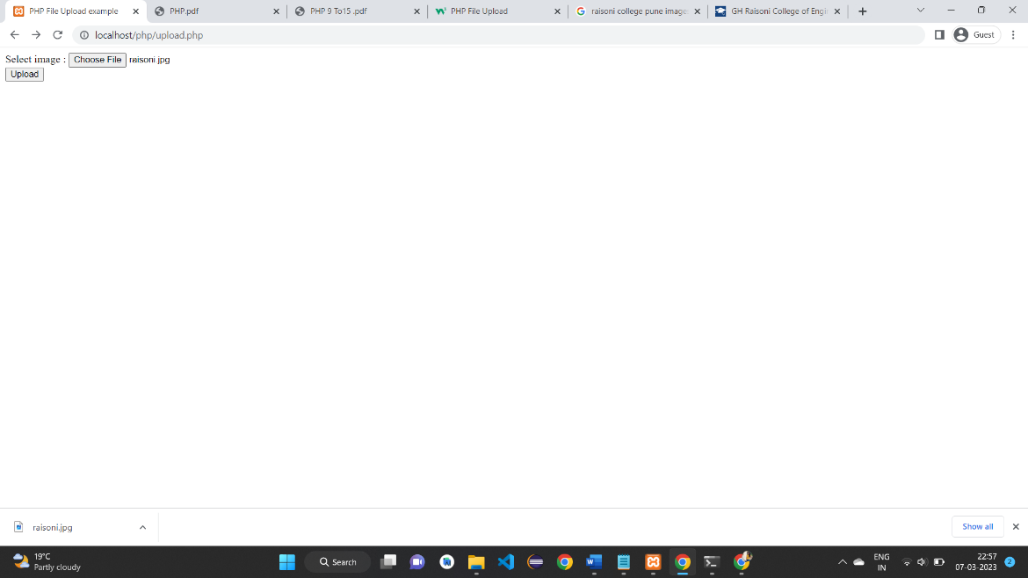

14. Write a PHP Code to make database connection, Create Data Base, Create Table In Mysql.

**Connection:**

<?php

$servername = "localhost";

$username = "root";

$password = "12345";

// I am Creating a connection here with MySQL.

$conn = mysqli_connect($servername, $username, $password);

// I am Checking connection here.

if (!$conn) {

die("Connection failed: " . mysqli_connect_error());

}

echo "My SQL Server Connected successfully";

?>

**Output:**

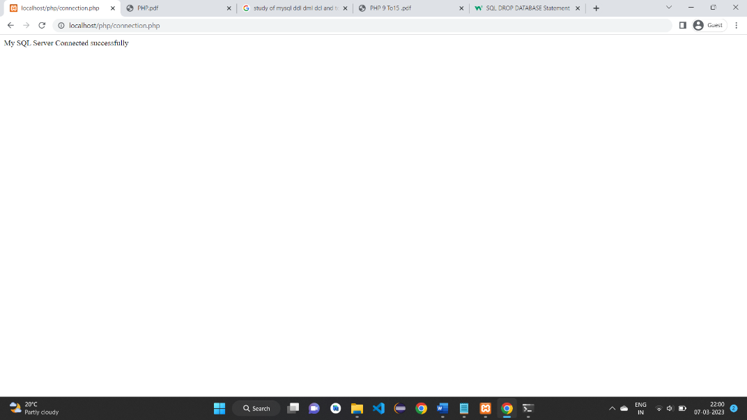

**Create Database:**

<?php

$servername = "localhost";

$username = "root";

$password = "12345";

// I am Creating a connection here with MySQL.

$conn = mysqli_connect($servername, $username, $password);

// I am Checking connection here.

if (!$conn) {

die("Connection failed: " . mysqli_connect_error());

}

// SQL qurey to Creating a database in MySQL.

$sql = "CREATE DATABASE School";

if (mysqli_query($conn, $sql)) {

echo "Database created successfully";

} else {

echo "Error! creating database: " . mysqli_error($conn);

}

mysqli_close($conn);

?>

**Output:**

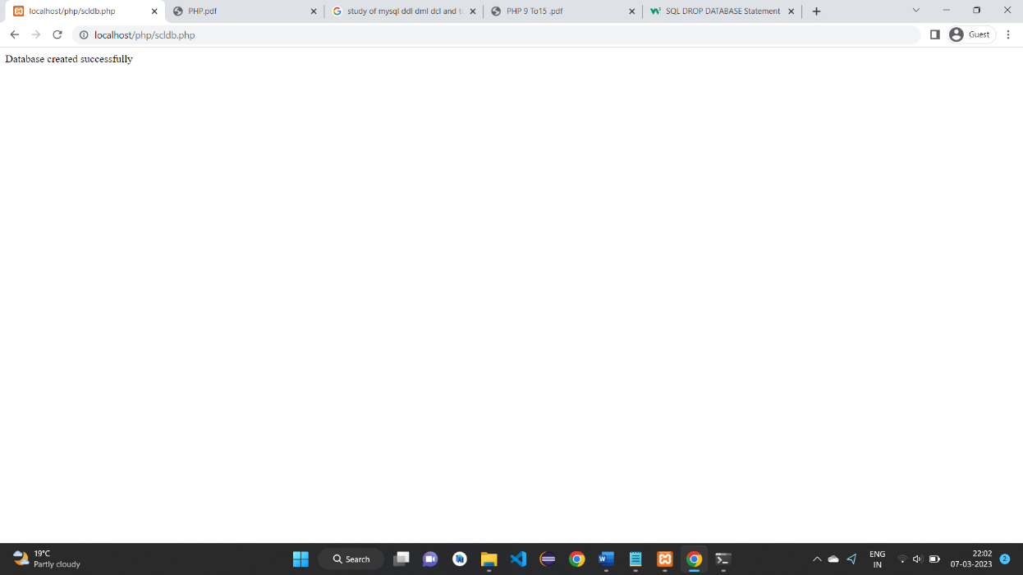

**Create Table:**

<?php

$servername = "localhost";

$username = "root";

$password = "12345";

$dbname = "School";

// I am Creating a connection here with MySQL.

$conn = mysqli_connect($servername, $username, $password, $dbname);

// I am Checking connection here.

if (!$conn) {

die("Connection failed: " . mysqli_connect_error());

}

// SQL query to creating a table in (School) database.

$sql = "CREATE TABLE students (

id INT AUTO_INCREMENT PRIMARY KEY,

stname VARCHAR(30) NOT NULL,

email VARCHAR(40),

mobile VARCHAR(10) NOT NULL

)";

if (mysqli_query($conn, $sql)) {

echo "Table students created successfully";

} else {

echo "Error! creating table: " . mysqli_error($conn);

}

mysqli_close($conn);

?>

**Output:**

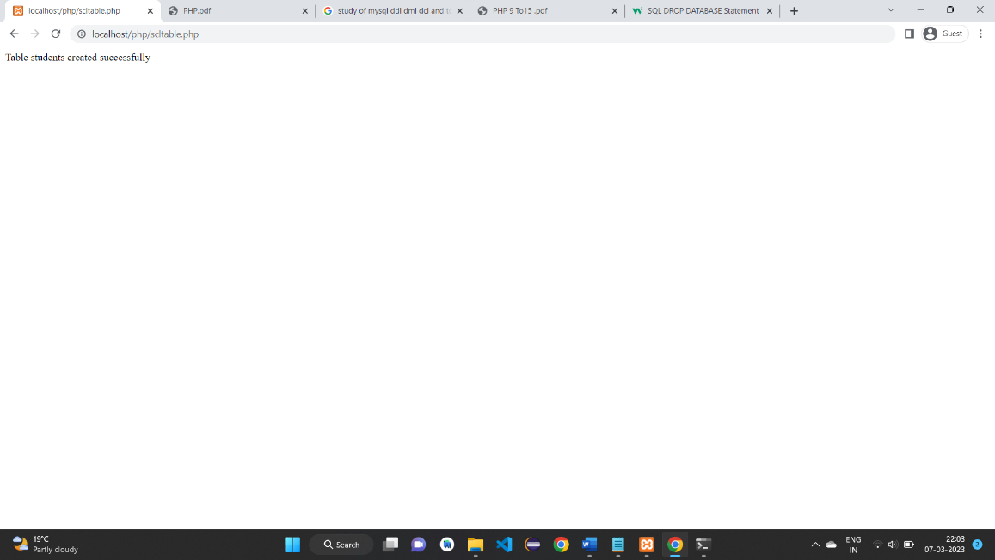

15. Write a PHP code Insert, Delete, Update, Select the Data From Data Base.

**Insert:**

<?php

$servername = "localhost";

$username = "root";

$password = "12345";

$dbname = "School";

// I am Creating a connection here with MySQL.

$conn = mysqli_connect($servername, $username, $password, $dbname);

// I am Checking connection here.

if (!$conn) {

die("Connection failed: " . mysqli_connect_error());

}

// SQL query to inserting data in students table.

$sql = "INSERT INTO students (stname, email, mobile)

VALUES ('Mohan', 'mohan@example.com', '1122334456')";

if (mysqli_query($conn, $sql)) {

echo "New record inserted successfully";

} else {

echo "Error: " . $sql . "<br>" . mysqli_error($conn);

}

mysqli_close($conn);

?>

**Output:**

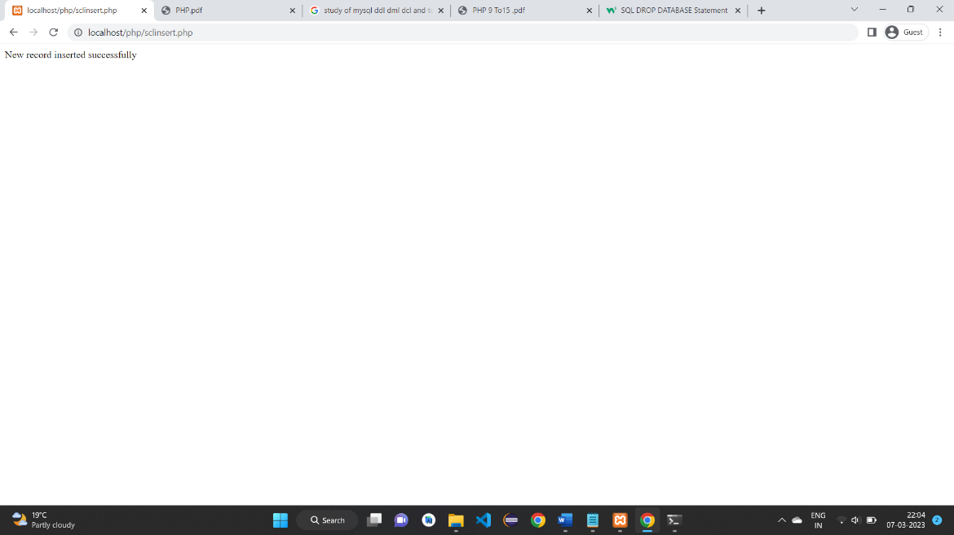

**Delete:**

<?php

$servername = "localhost";

$username = "root";

$password = "12345";

$dbname = "School";

// I am Creating a connection here with MySQL.

$conn = mysqli_connect($servername, $username, $password, $dbname);

// I am Checking connection here.

if (!$conn) {

die("Connection failed: " . mysqli_connect_error());

}

// SQL query to deleting record.

$sql = "DELETE FROM students WHERE id=1";

if (mysqli_query($conn, $sql)) {

echo "Record deleted successfully";

} else {

echo "Error! deleting record: " . mysqli_error($conn);

}

mysqli_close($conn);

?>

**Output:**

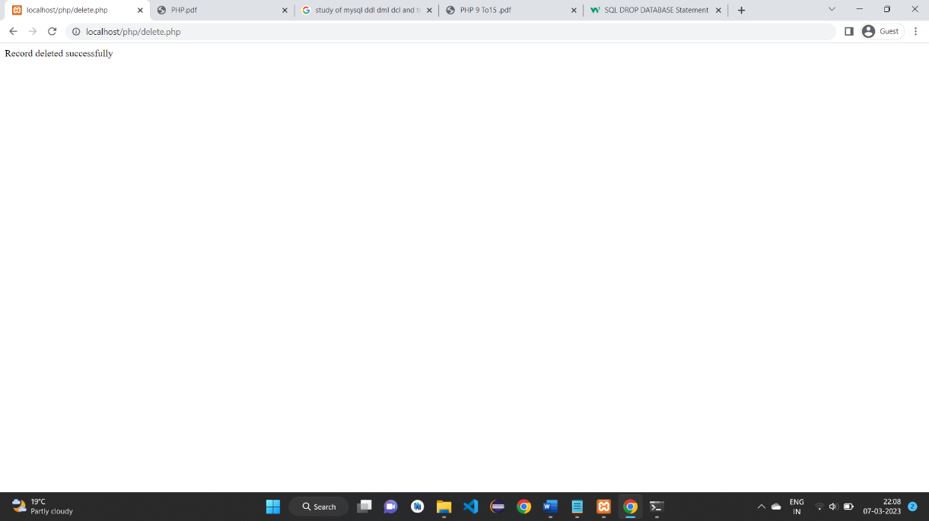

**Update:**

<?php

$servername = "localhost";

$username = "root";

$password = "12345";

$dbname = "School";

// I am Creating a connection here with MySQL.

$conn = mysqli_connect($servername, $username, $password, $dbname);

// I am Checking connection here.

if (!$conn) {

die("Connection failed: " . mysqli_connect_error());

}

// SQL query to updating record.

$sql = "UPDATE students SET stname='Sunil' WHERE mobile='1122334456'";

if (mysqli_query($conn, $sql)) {

echo "Record updated successfully";

} else {

echo "Error! updating record: " . mysqli_error($conn);

}

mysqli_close($conn);

?>

**Output:**

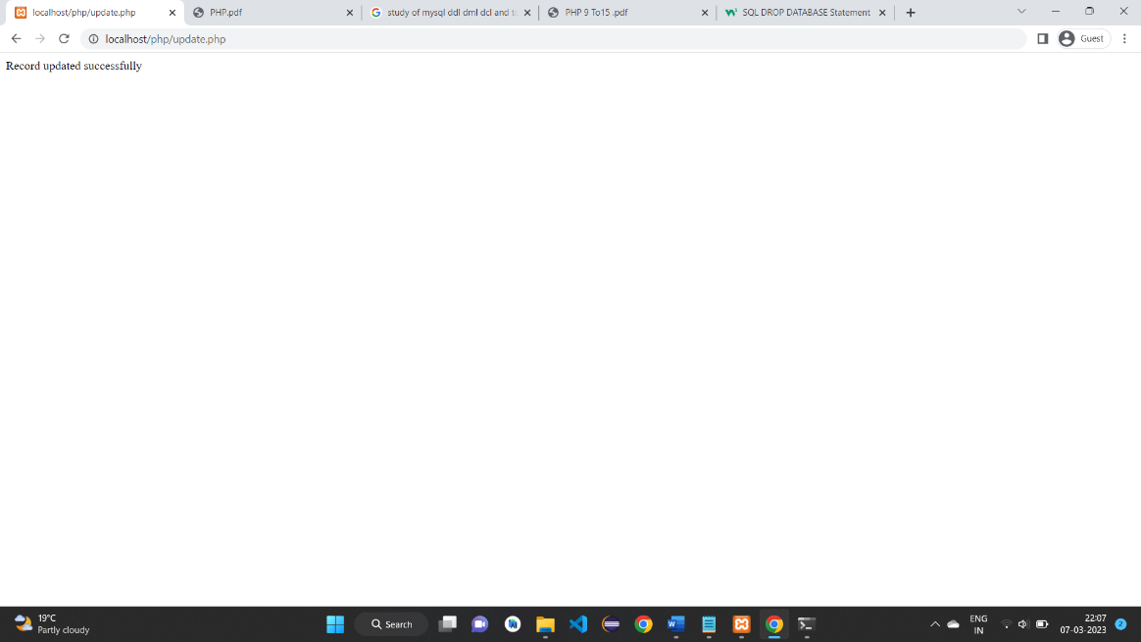

**Select:**

<?php

$servername = "localhost";

$username = "root";

$password = "12345";

$dbname = "School";

// I am Creating a connection here with MySQL.

$conn = mysqli_connect($servername, $username, $password, $dbname);

// I am Checking connection here.

if (!$conn) {

die("Connection failed: " . mysqli_connect_error());

}

// SQL query to selecting all record from table

$sql = "SELECT id, stname, email, mobile FROM students";

$result = mysqli_query($conn, $sql);

if (mysqli_num_rows($result) > 0) {

while($row = mysqli_fetch_assoc($result)) {

echo "<b>Id:</b> " . $row["id"]. ", <b>Name:</b> " . $row["stname"]. ",

<b>Email:</b> " . $row["email"]. ", <b>Mobile:</b> " . $row["mobile"]. "<br>";

}

} else {

echo "no record found";

}

mysqli_close($conn);

?>

**Output:**

